**PRANAV SANDEEP RAIKAR**

**D10A 43**

**EXPT 3:**

**AIM: Installation and configuration of NS2.**

**Introduction to Tcl Hello Programming**

**INSTALLATION OF UBUNTU NS 2**

**STEP 1 :** 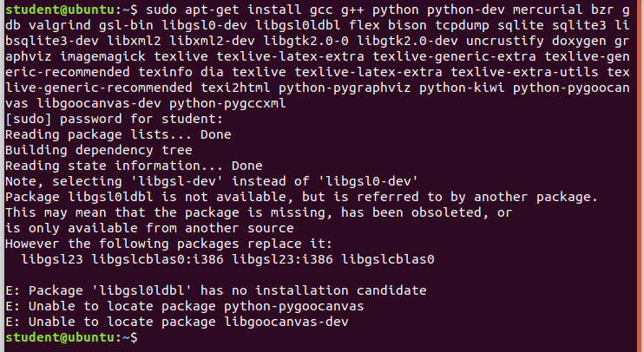

**STEP 2 :**



**STEP 3 :** 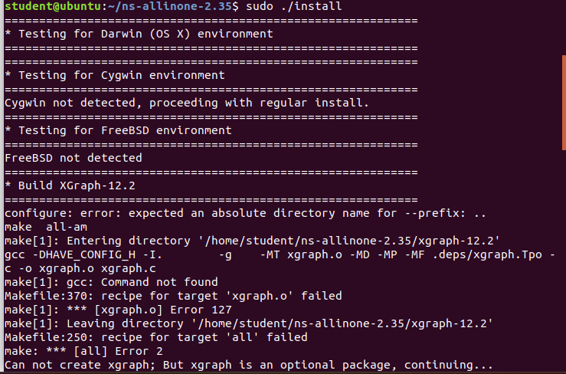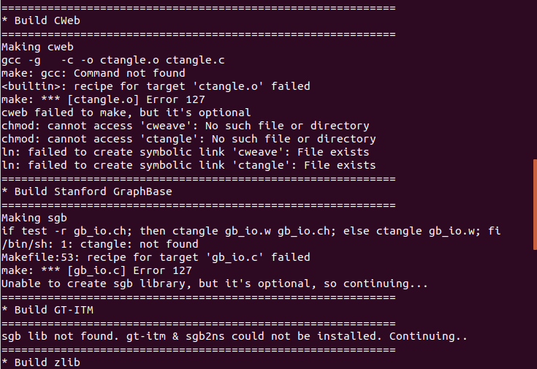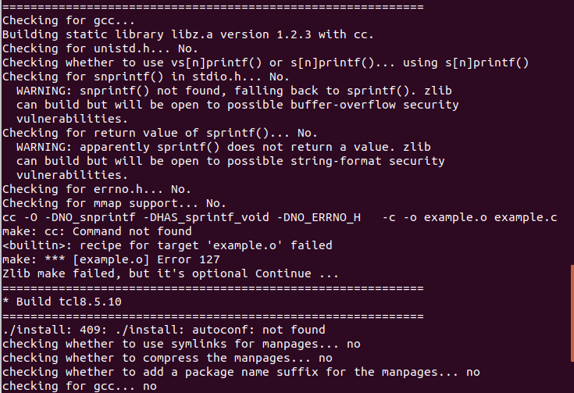

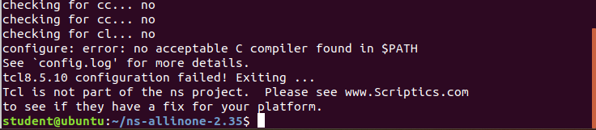

**STEP 5 :**

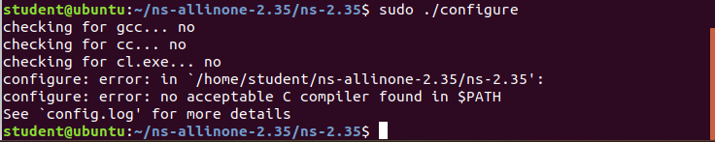

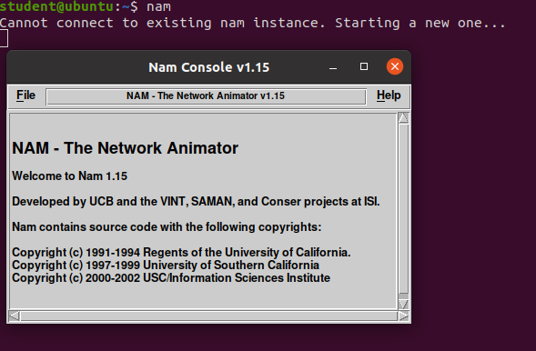

**END**